Robotics – Final Exam Substitute Report

202135584 차준하(Jun Ha Cha)

**1. Drawing figures, describe the scenario you want to show by using an educator vehicle appropriately.**

**Topic:** A robot that automatically closes the door.  
  
**Robot name:** Closer  
  
**The robot's goal:** If the door needs to be closed except in special cases, the robot closes the door on its own.

**The focus of the work:** practicality / problem solving

**Motivation for selection:** Being alone in the room.In some cases, the wind automatically opened the door, and parents or younger siblings often forgot to close the door when they came in, or they came into the room and left the door unattended. Whenever that happened, I had to get up to close the door myself, and I thought how nice it would be if someone closed the door automatically.  
  
**Expected question:**  
Case 0. How will the car robot push the door?  
Case 1. Can you push the door properly while rotating the curve?  
Case 2. What do you do when you have to leave the door open, such as ventilation?  
Case 3. What if the robot's sensor is recognized even when passing by?  
Case 4. How will you prevent the robot from running even if you open and close the door yourself?  
  
**Problem Solving:**  
Solve case 0. Install a plate in contact with the front door of the robot and push it out.  
Solve case 1. Use a curved plate rather than a flat plate so that it can be pushed at any angle.  
Solve case 2. In such a special case, the robot can be powered off.  
Solve case 3+4. Adjust the range of the robot's ultrasonic sensor and program the program to start when the object is recognized and the object recognition persists for more than 5 seconds.  
  
**Operation Scenario:**  
Start: The red starting point is the starting point of the robot.  
1. When the robot's ultrasonic sensor recognizes an object, it proceeds with recognition for 5 seconds, and if the object is recognized even after 5 seconds, it issues a start alarm and executes the program.  
2. Curved tape with black tape a little inside the door than the opening range. Through the color sensor, if the robot recognizes black, moves right (inside // stores the number of movements by +1 in the cnt variable) and does not recognize black, it recognizes the curve in zigzag through the code that moves left (outside) again and pushes the door to the glass plate in front.  
3. When the door is closed, the touch sensor on the left side of the robot recognizes the wall. If the wall is recognized (blue point), a completion alarm sound is issued and the cnt variable stored in No. 2 proceeds backward by the same number of times and returns to its original position.  
Finally: When the vehicle arrives at the start point again while moving backward, another touch sensor existing behind the vehicle recognizes the rear wall, makes an end sound and stops.

**Figure 1).** Background explanation.

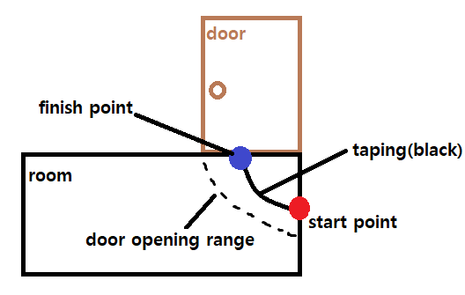

**Figure 2).** How to move a car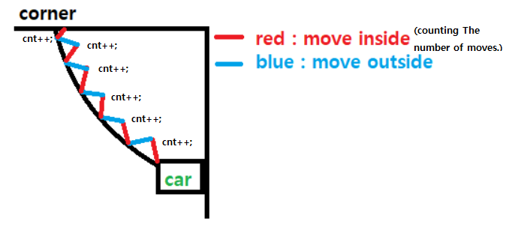

**Figure 3).** Introducing the structure of the car.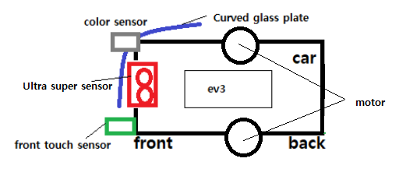

**2. Write a list of RobotC functions used in scenario 1 above and explain each function in details.** (There are many parts explained in question 1. (Re-explaining)

**<Introduction of functions>**

**1. Alarm sound.**  
- Each different notification sound for (start/close success/end)

**2. Ultrasonic sensor.**  
- Sensor recognition is performed at the start point, and sensor recognition is performed for 5 seconds to reduce errors. If the sensor is not recognized within 5 seconds, it is terminated again, and if the sensor is recognized even after 5 seconds, the movement code is executed.

**3. Move. (Zigzag)**  
- When recognizing black through color detection, move inward and cnt variable +1, move outward when black is not recognized.

**4. Touch sensor.**  
- After successfully closing the door, the touch sensor recognizes the wall and executes the reverse code.

**5. Reverse.**  
- Repeat the reverse code as much as the cnt variable stored in the zigzag movement.

**6. Glass plate.**  
- Install a curved glass plate to push the door regardless of angle during zigzag movement.

**3. Write a full code using RobotC.**

**#pragma config(Sensor, S3, reflectValue, sensorEV3_Color)**

**#pragma config(Sensor, S4,**  **ultra,**   **sensorEV3_Ultrasonic)**

**#pragma config(Sensor, S1, touchSensor, sensorEV3_Touch)**

**#define THRESHOLD 50**

**task main()**

**{**

**bool door_check1 = false; // door Recognition variable1.**

**bool complete_program_back = false; //backward start variable.**

**int cnt = 0; // Measurement variable of the number of movements.**

**while(1)**

**{**

**if(SensorValue(ultra) < 15) // Recognizing the door for the first time. (one step)**

**{**

**wait1Msec(5000); // wait 5 seconds.**

**if(SensorValue(ultra) < 15) // If robot recognize the door even after 5 seconds,(two step)**

**{**

**playSound(soundBlip);**

**sleep(1000);**

**door_check1 = true;**

**displayTextLine(0, "%s" , "start Program!"); // display "start program!"**

**break;**

**}**

**}**

**}**

**while(door_check1 == true)**

**{**

**if(getTouchValue(touchSensor) == 1) // When a car hits the wall after closing the door and recognizes the touch sensor,**

**{**

**complete_program_back = true;**

**playSound(soundBlip);**

**sleep(1000);**

**break; // out while syntex.**

**}**

**if(SensorValue(reflectValue) > THRESHOLD)**

**{//no recognize black. >>> move the outside.**

**motor[motorB] = 2; // Motor[B] is the left wheel.**

**motor[motorC] = 10; // Motor[C] is the right wheel.**

**wait1Msec(100);**

**}**

**else if(SensorValue(reflectValue) < THRESHOLD)**

**{//recognize black. >>> move the inside.**

**cnt++; // Increase or decrease of 'cnt' variables for backward movement.**

**motor[motorB] = 10; // Motor[B] is the left wheel.**

**motor[motorC] = 2; // Motor[C] is the right wheel.**

**wait1Msec(100);**

**}**

**}**

**while(complete_program_back == true && cnt != 0) // Back to robot original position.(red point)**

**{**

**motor[motorB] = -10;**

**motor[motorC] = -2;**

**wait1Msec(100);**

**motor[motorB] = -2;**

**motor[motorC] = -10;**

**wait1Msec(100);**

**cnt--; // As much as you moved when you first closed the door, go backward.**

**}**

**displayTextLine(0, "%s" , "End Program!"); // display "end program!"**

**playSound(soundBeepBeep); // Program successfully ended alarm sound.**

**sleep(1000); // end**

**}**